**Serena Project**

**Prototype design :**

**Requirements :**

* Confortable (reduced size).
* Protection (casing to protect from the cables).
* Simple design (easy to use, to understand for blind people).
* Controllable (can be turn on or off).

**The Idea :**

Our prototype is a glove with a technological part in the middle of the hand :

* It’ s using little components like the mini Arduino card to respect the hand size.
* It’s covering by a piece of fabric to allow the user protection.
* We give it a large hole in the right left to reach the slide switch.
* The glove allows the ability to wear the prototype easily.

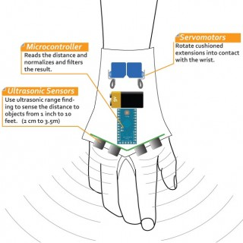 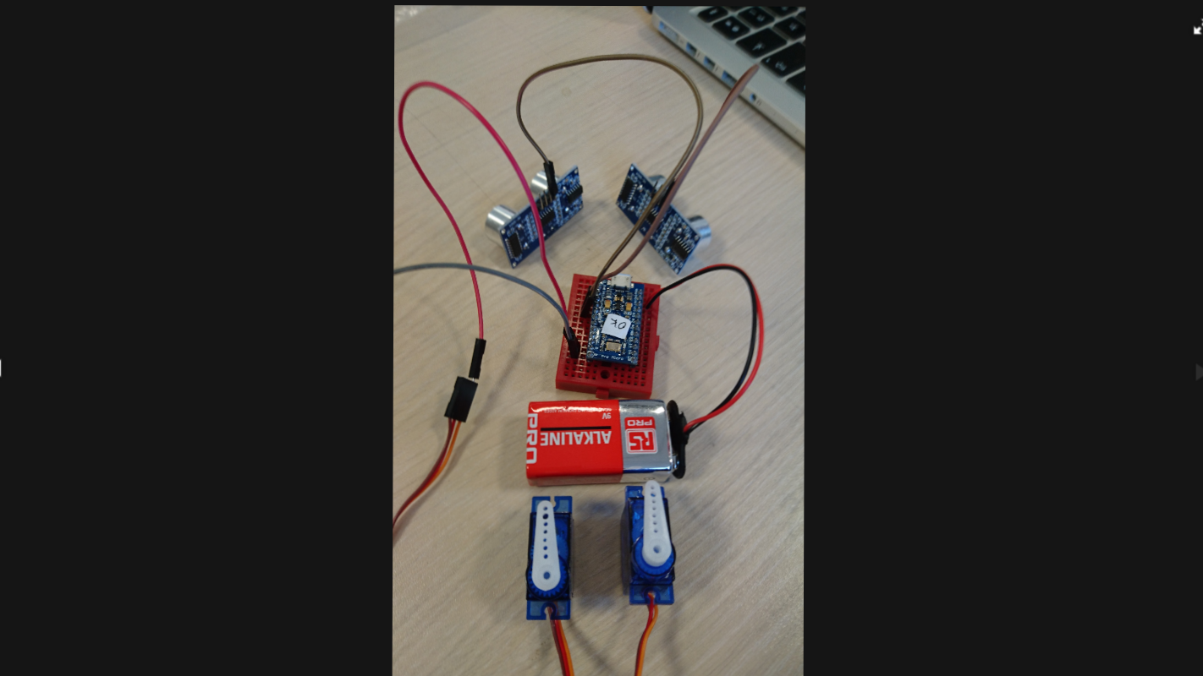

(see of the components inside the casing)

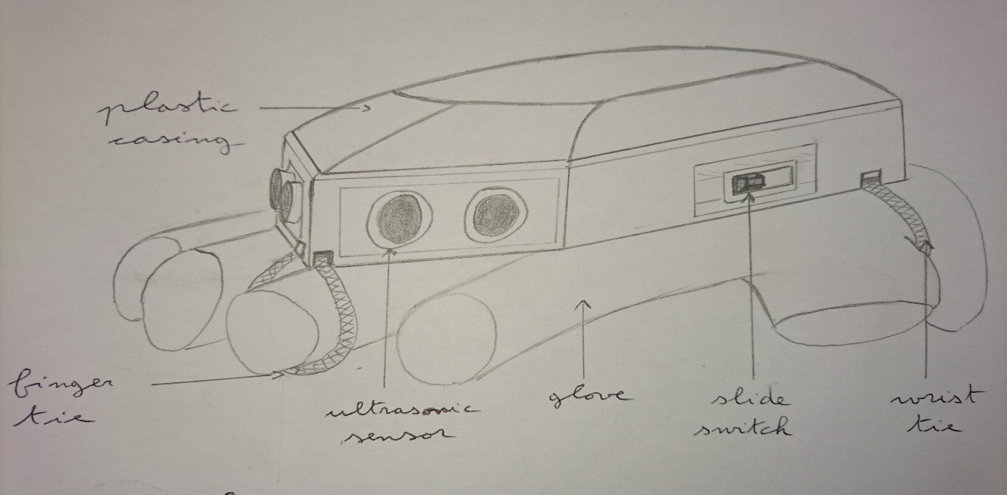

(final product sketch)

**During the experimentations :**

**Description :**

A volunteer with a blindfold will move in a aera with the prototype in his right hand.

He will describe the feelings he get with the glove when he was near of a obstacle.

He will try to go in differents places and avoid the obstacles, even the persons he runs into.

**Tasks :** We have to check :

* The good navigation, orientation with the prototype,
* The ability to find the slide switch,
* The weight of the glove,
* The stability of the hand when the glove is on it,
* The good working of ultrasonics sensors,
* The vibrations intensity depending on the distance between the user and the obstacles,
* The ablility to take on and take off the prototype easily.